EXPERIMENT – 10
AIM :
To develop Python programs that create a line plot and a bar plot for monthly sales data using Matplotlib.
ALGORITHM :
- Import Matplotlib library.
- Store months and sales values in lists.
- Use plt.plot() to create a line plot.
- Use plt.bar() to create a bar plot.
- Label the axes and give a title.
- Display the plots using plt.show().

CODE :
CODE FOR LINE PLOT
import matplotlib.pyplot as plt

months = ['Jan', 'Feb', 'Mar', 'Apr', 'May', 'Jun']
sales = [12000, 15000, 17000, 14000, 18000, 20000]

plt.plot(months, sales, marker='o')
plt.xlabel("Months")
plt.ylabel("Sales")
plt.title("Monthly Sales - Line Plot")
plt.grid(True)
plt.show()

CODE FOR BAR PLOT
import matplotlib.pyplot as plt

months = ['Jan', 'Feb', 'Mar', 'Apr', 'May', 'Jun']
sales = [12000, 15000, 17000, 14000, 18000, 20000]

plt.bar(months, sales)
plt.xlabel("Months")
plt.ylabel("Sales")
plt.title("Monthly Sales - Bar Plot")
plt.show()

INPUT :
months = ['Jan', 'Feb', 'Mar', 'Apr', 'May', 'Jun']
sales = [12000, 15000, 17000, 14000, 18000, 20000]

OUTPUT :
CODE FOR LINE PLOT
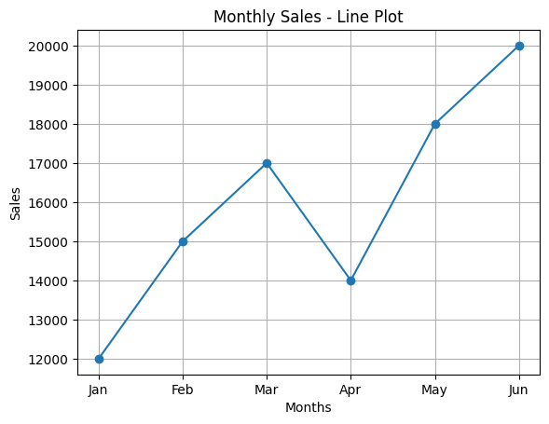

CODE FOR BAR PLOT
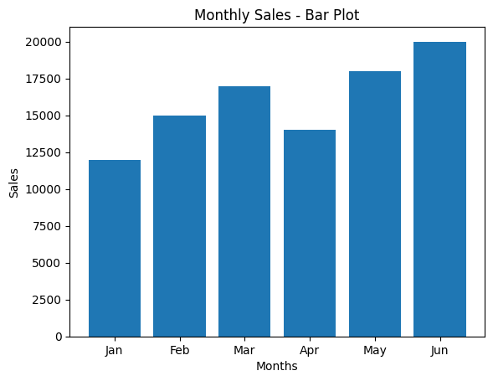

RESULT :
The program successfully generated a line plot and a bar plot to visualize the monthly sales data.

